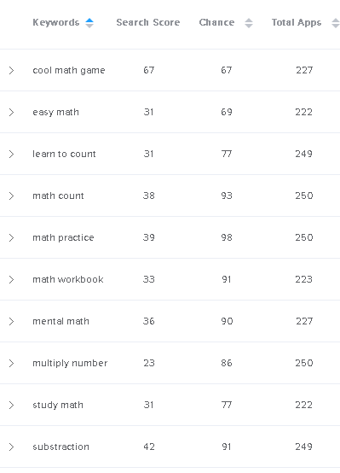

**Suggested Title: Math Made Easy – Easy Math Practice & Workbook**

**Short title:**

Learn to count, abacus (mental math), subtraction, division, & multiply numbers.

**Long description:**

Study math with Math Made Easy! Learn to count up to 5, 10, and 20. You can also learn addition-subtraction, abacus (mental math), division, and how to multiply numbers. Our simple math workbook will make you feel as if you’re playing a cool math game not study math. It’s fun, engaging, and addictive. Furthermore, it’s completely FREE with no ads so it’s very comfortable to use. Take your time a few minutes a day to practice and study Math with our Math Made Easy – Math Workbook for kids and young learner.

Many kids don’t like to study Math count or working with numbers. We try to make the process to study math count and numbers as fun, engaging, and even addictive to them. Math Made Easy makes Math Workbook like a cool math game for kids and young learners. The problems are presented in colorful pictures so they can visualize it easily. They are also presented in level system: they need to complete previous tasks to be able to move on to the next. If you are a parent or a teacher looking for a Math Workbook that your kids or students will like, try out our app. It’s 100% FREE because our aim is to improve math count & number skill for young learners.

MATH MADE EASY – EASY MATH PRACTICE & MATH WORKBOOK SECTIONS:

* Learn to count up to 5.
* Learn to count up to 10.
* Learn to count up to 20.
* Practice Addition and Subtraction.
* Abacus (mental math)
* Learn how to multiply numbers and divide them

It doesn’t take a lot of work to master counting and mathematic. Just by taking a few moments time to solve problems on our Math workbook you will be able to significantly improve your Math skills. You will realize that Mathematic is so much fun, just like playing number puzzle or cool math games!

---

Please spread the word! Rate and share Math Made Easy to your friends & family!